FINAL PROJECT

|  |  |
| --- | --- |
| Date | 24.09. 2022 |
| Team ID | PNT2022TMID41917 |
| Project Name | Smart Solution for Railways |

# Abstract:

Even with greatest of ideas to avoid railway accidents, many trains accidents still happen worldwide. This paper shares an idea on how to avoid train collision by using an automated control incorporated in the trains. In this proposed paper we have implemented ideas such as pre-crashing using RFID sensor, ultrasonic sensor in-order to choose an array of commands which would run as per the conditional algorithm created in the microcontroller. We would also have a EPM to control the speed of the motor to lessen speed. This system will be more efficient since it was fully automated and also it was cost effective.

# Introduction:

We wanted to be apart of our surrounding with some change and advancement so that it can bring the better life of the middle class and lower class people to travel in high secutity and advanced locomotions .the train is one and only most widely used transportion,and not only for this they are used for goods transportion also .Indian railways are not able to facilate the customer properly due to crowded amount of people. Statistics show that the leading cause of death by injury in railways traffic accidents(two train collision each other). There are number of causes for which an accident can occur, some of them are; lack of training

for driving or less experinessed, use of mobile phone while driving, unskilled drivers, driving while intoxicated, bad railway tack condition, overloading in tain and negligence traffic management. In this survey paper, we briefly review selected railway accidents detection techniques and propose a solution. Rear end crashes occur mainly due to obstracle and crack in tracks.According to recent statistics, a major percentage of train accidenthappen due to not proper survillance of railway track

In feb a train was travelling in the forest range of bihar state were five elephant were hit by the train which was moving ata high speed. Collisions of train happened in last year june were the indian railway minister felt guilty. a moderate rate of 2% fatalities compared to all other types of crashes, it represents the highest rate of injuries that is 22% and also the highest percentage of loss of life, being 28%. There have been enormous efforts to develop an algorithm in the field of automation of smart railways Systems (ASRS).An intelligent in railways transportation system (IRTS) is an advanced application, which aims to provide services and protect the life of people inside and also outside the railway.

# Related works :

Most of the public transportation infrastructure in European cities is easily accessible. The majority of the tram/train stations are located in an open and "gate-free" environment, easy available to everyone and hence introduces potential malfunctions in the system. This is why fare dodging (hopping on the tram/train without paying for a ticket) is simple. This paper suggests a conceptual framework and architecture to capture free riders (fare dodgers) in an early stage by using a RFID distance scan combined with people counting techniques as a tool to locate and monitor passengers. As a case study this paper uses the ticketing system in

The Netherlands. It is a RFID-based ticketing system which uses a smartcard called OV-Chip card. It explains the current setup in The Netherlands, systems and architectures used and shows where possible problems and improvements could be achieved. An experiment is done to measure certain basic distance read ranges in different situations and locations. The results show that by making use of a different system architecture (RFID technology and People Counting Techniques) an improvement in catching free rides (faredodgers) in a much earlier stage is inspectors.

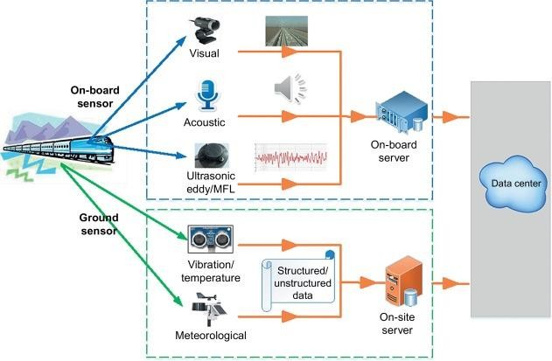

Wheel set is one of the vital components of the train.

Normally, the wheels are regularly detected by using ultrasonic technology to check cracks, especially in wheel rim. In order to eliminate the failure risks of wheels, daily dynamic wheel set inspecting system is needed during the light maintenance period. A way-side arrayed ultrasonic technology is described in this paper to

detect wheel cracks. By using a specially designed track structure, the arrayed ultrasonic probes are arranged between the double- track for wheel rim inspection .From the testing results, Φ3mm side drill hole in the wheel rim can be well detected at the running speed of 30～40km/h. The noise is effectively suppressed by filtering algorithm, thus to improve the signal to noise ratio and the positive alarming rates. At present, the technology has been successfully used in Chinese high-speed train maintenance centers, rolling stocks and locomotive maintenance depots.

Numerical investigations are carried out to assess the possible use of vibration measurements to identify the presence of a fatigue crack in railway axles. A non-linear finite element model of a cracked axle, reproducing the crack breathing mechanism, is introduced. The solid model of the axle is built in the ABAQUS FEM software and a crack is introduced in it. Numerical simulations are presented for two different types of axle: hollow ones, as in passenger trains, and solid ones, as in freight trains. Simulation are carried out for different possible locations of the crack and different measuring points for the monitoring equipment. Results indicate that the presence of a crack in the shaft affects not only the vertical vibration signal, but also the horizontal (perpendicular to the axle axis) one, generating harmonic components of bending vibration at frequencies that are multiple integers of the frequency of revolution of the axle. Results revealed also that the horizontal vibration provides promising indicators of axle fault development because the effect of various sources of disturbance.

# The IOT –Connected Trains:

The IOT can interconnect all objects and devices that were previously not part of a network for predictive analytics. Its application increases safety, efficiency and ease of use with train

management systems. Control and surveillance systems reduce the risk of collisions and regulate speed. Advanced consumer technologies help maximise connectivity and allow passengers to continue their activities on smart devices while travelling. Train-to- train communication through the cloud enables operators to transmit data about equipment, tracks and stations among themselves.

The IOT enables monitoring of areas on railway crossings remotely, such as barrier operations and end positions, switch end positions, space between barriers, system operations, connections and signals. This allows users to accelerate their projects, from engineering and runtime to maintenance with fast detection and localisation of errors and faults.

Here are some potential use cases presented by rail operators for using IOT to create a connected railway.

* A journey planner application could recommend the fastest or most comfortable current trip allowing for road conditions to the station, live train times, available car parking capacities, passenger loading, etc., allowing passengers to make informed choices about what option will provide them with the best experience according to their personal circumstances, for example whether it is more important to have the shortest journey time, or to be guaranteed a seat. Allowing the inclusion of historic data will enable evaluation not only for a current trip, but also in a predictive way for a trip planned at a future date, based upon what is normal for the planned day and time of travel
* Combining passenger loading information from trains with social networking apps will help spread demand.

# Conclusion:

By using this Autonomous vehicle for purpose of railway track inspection and crack detection, it will have a great impact in the maintenance of the tracks which will help in preventing train accidents to a very large extent. The regions where manual inspection is not possible, like in deep coal mines, mountain regions and dense thick forest regions can be easily done using this vehicle. By using this vehicle for the purpose of Railway track inspection and crack detection and automated SMS will be sent to pre-defined phone number whenever the vehicle sensors detect any crack or deformation. This will help in maintenance and monitoring the condition of railway tracks without any errors and thereby maintaining the tracks in good condition, preventing train accidents to very large extent Railway track crack detection autonomous vehicle is designed in such a way that it detects the cracks or deformities on the track which when rectified in time will reduce train accidents.